**Spring boot JDBC with Maven:**  
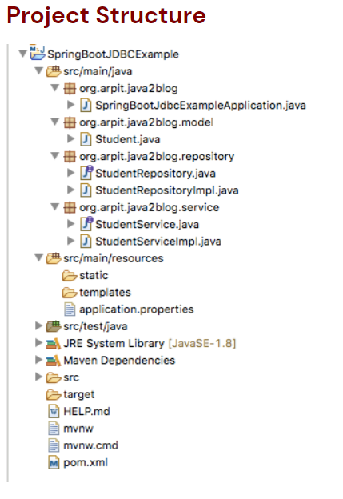

And

**JDBC Spring without Mavan**  
